**LITERATURE**

**SURVEY**

**PAPER 1**

# Internet of Things-Based Baby Monitoring System for Smart Cradle

**This paper appears in:** International Journal of Advanced Research in Electrical, Electronics And Instrumentation Engineering

**Date of Publication:** September 2012

# Author(s): Miss.S.R. Jadhav

**Abstract:-** The current number of working mothers has greatly increased. Subsequently, baby care has become a daily challenge for many families. Thus, most parents send their babies to their grandparents’ house or to baby care houses. However, the parents cannot continuously monitor their babies’ conditions either in normal or abnormal situations. Therefore, an Internet of Things-based Baby Monitoring System (IoT-BBMS) is proposed as an efficient and low-cost IoT-based system for monitoring in real time. We also proposed a new algorithm for our system that plays a key role in providing better baby care while parents are away. In the designed system, Node Micro-Controller Unit (NodeMCU) Controller Board is exploited to gather the data read by the sensors and uploaded via Wi-Fi to the AdaFruit MQTT server. The proposed system exploits sensors to monitor the baby’s vital parameters, such as ambient temperature, moisture, and crying. A prototype of the proposed baby cradle has been designed using Nx Siemens software, and a red meranti wood is used as the material for the cradle. The system architecture consists of a baby cradle that will automatically swing using a motor when the baby cries. Parents can also monitor their babies’ condition through an external web camera and switch on the lullaby toy located on the baby cradle remotely via the MQTT server to entertain the baby. The proposed system prototype is fabricated and tested to prove its effectiveness in terms of cost and simplicity and to ensure safe operation to enable the baby-parenting anywhere and anytime through the network. Finally, the baby monitoring system is proven to work effectively in monitoring the baby’s situation and surrounding conditions according to the prototype.

**PAPER 2**

# Intelligent Baby Monitoring System

**This paper appears in:** International Journal of Advanced Research in Electrical, Electronics And Instrumentation Engineering

**Date of Publication:** September 2012

**Author(s):** Dr. J. Abdul Jaleel, SibiSalim, Aswin.R.B

**Abstract:-** This paper presents a design of a Baby Monitoring System based on the GSM network. A prototype is developed which gives a reliable and efficient baby monitoring system that can play a vital role in providing better infant care. This system monitor vital parameters such as body temperature, pulse rate, moisture condition, movement of an infant and using GSM network this information is transferred to their parents. Measurements of this vital parameters can be done and under risk situation conveyed to the parents with alarm triggering system to initiate the proper control actions. The system architecture consist of sensors for monitoring vital parameters, LCD screen, GSM interface and a sound buzzer all controlled by a single microcontroller core. KeywordsBaby monitoring, vital parameters, microcontroller, GSM network. This paper presents a style of a Baby observance System supported the GSM network. A model is developed which supplies a reliable and economical baby observance system that may play an important role in providing higher kid care. this technique monitor important parameters like voice, movement of AN kid and exploitation GSM network this info is transferred to their oldsters. Measurements of this important parameters are often done and below risk state of affairs sent to the fogeys with SMS and vocation system to initiate the right management actions. The system design incorporates voice sensors for observance important parameters, GSM interface controlled by one microcontroller core

**PAPER 3**

# Intelligent Baby Monitoring System

**This paper appears in:** International Journal of Advanced Research in Electrical, Electronics And Instrumentation Engineering

**Date of Publication:** September 2012

**Author(s):** Dr. J. Abdul Jaleel, SibiSalim, Aswin.R.B

**Abstract:-**. This project presents a baby monitoring system for busy parents so that they can ensure the proper care and safety of their babies. This system can detect the baby's motion and sound; especially crying and video output of baby's present position can be displayed on a display monitor so that the mother or another responsible person can watch the baby while away from him or her. This baby monitoring system is capable of detecting motion and crying condition of the baby automatically. The Raspberry Pi B+ module is used to make the total control system of the hardware, condenser MIC is used to detect baby's crying, PIR motion sensor is incorporated to detect baby's movement and Pi camera is used to capture the baby's motion. A display is used to have video output of sleeping baby. Finally, the developed hardware is tested to analysis the capability of detecting the motion and crying sound of baby as well as the video output. Key ResultThis proposed system can provide an easier and convenient way for busy parents in terms of taking care of their babies. This paper represents a design of smart infant cradle which gives reliable and cost-efficient baby monitoring system. It plays a important role by giving better baby care. Smart infant cradle system swings automatically when baby continuously cry for stipulated time. The cradle system contain set of sensors, the sound sensor is mainly used for detect baby cry voice, the moisture sensor is used for detect the wetness of the diaper and methane sensor is used for detecting methane content. Servo motor is used for swing the cradle.

**PAPER 4**

# Automated Alarm System for Diaper Wet Using GSM

**This paper appears in:** International Journal of Advanced Research in Electrical, Electronics And Instrumentation Engineering

**Date of Publication:** September 2012

**Author(s):** Dr. J. Abdul Jaleel, SibiSalim, Aswin.R.B

**Abstract:-**. Wearing a wet diaper for prolonged periods, cause diaper rash. This paper presents an automated alarm system for Diaper wet. The design system using an advanced RF transceiver and GSM system to sound an alarm on the detection of moisture in the diaper to alert the intended person to change the diaper. A wet diaper detector comprises an elongated pair of spaced fine conductors which form the wet sensor. The sensor is positioned between the layers of a diaper in a region subject to wetness. The detector and RF transmitter are adapted to be easily coupled to the protruding end of the elongated sensor. When the diaper is wet the resistance between the spaced conductors falls below a pre-established value. Consequently, the detector and RF transmitter sends a signal to the RF receiver and the GSM to produce the require alarm. When the diaper is changed, the detector unit is decoupled from the pressing studs for reuse and the conductor is discarded along with the soiled diaper. Key ResultOur experimental tests show that the designed system perfectly produces the intended alarm and can be adjusted for different level of wet if needed.

**PAPER 5**

# Automatic E-Baby Cradle Swing based on Baby Cry

**This paper appears in:** International Journal of Advanced Research in Electrical, Electronics And Instrumentation Engineering

**Date of Publication:** September 2012

**Author(s):** Dr. J. Abdul Jaleel, SibiSalim, Aswin.R.B

**Abstract:-**. There is a need to develop a new low cost indigenous electronic cradle because the existing cradles are imported and costly. This paper presents the design and implementation of a new indigenous low cost E-Baby Cradle that swings automatically when baby cries, for this it has a cry analyzing system which detects the baby cry voice and accordingly the cradle swings till the baby stops crying. The speed of the cradle can be controlled as per the user need. The system has inbuilt alarm that indicates two conditions – first when the mattress is wet, which is an important parameter to keep the baby in hygienic condition, second when baby does not stop crying with in a stipulated time, which intimated that baby needs attention. This system helps parents and nurses to take care of babies without physical attention. General Terms E-Baby cradle, low cost, indigenous. Using electronic devices is not limited to adults or to specific time or place. Children use different types of mobile devices with no constrains. Guardians concern

about the effect of the technical explosion on their children development. Controlling,

monitoring, and managing approaches are in need to help in overcoming some of these

worries. This project gives insight in approaches to monitor and control children

electronic devices. The project includes an overview of the related research efforts

that allow guardians to manage and monitor data, applications, or services available in

kids’ mobile devices. The main challenge is to balance privacy and flexibility with the

ease of use. The project also includes the implementation of an Android app called

Time’s Up.

**PROJECT OVERVIEW**

**Introduction:** At present, female participation in the work force in the industrialized nations has greatly increased, thereby affecting infant care in many families. Both parents are required to work due to the high cost of living. However, they still need to look after their babies, thereby increasing workload and stress, especially of the mother. Working parents cannot always care for their babies. They either send their babies to their parents or hire a baby caregiver while they are working. Some parents worry about the safety of their babies in the care of others. Thus, they go home to check on their babies during their free time, such as lunch or tea break. A baby monitoring system that can monitor the babies’ condition real time is proposed to solve these problems. A baby monitoring system consisting of a video camera and microphone without limitations of coverage. It can send data and immediately notify the parents about urgent situations, thereby shortening the time needed to handle such scenarios. Generally, babies cry because they are hungry, tired, unwell, or need their diaper changed.

**Problem:**Under fast-paced life conditions, everyone is busy in their professional life including parents. They leave the house early in the morning and come back before dinner time. Even the mothers are working. Thus, they do not have sufficient time to take care of their babies. Not all parents could afford a nanny to help them with their children. Then, after working for long hours, the mothers still have to manage the house and take care of their babies simultaneously.

**Solution:** Parents might not have the time to soothe their baby to sleep or rock their baby back to sleep in the middle of the night. Studies about the effect of rocking a baby have been carried out and found that babies sleep better while being rocked or swung lightly because the rhythmic movement mimics the gentle rocking they felt while in their mothers’ womb. Most available automated cradles are designed to rock non-stop. However, the rocking movement can make the baby nauseous and uncomfortable. Thus, allowing the automated cradle to rock the baby to sleep in the middle of the night is also a problem.

**The approach:**To address these challenges, we designed and fabricated a baby monitoring system for a smart cradle using NodeMCU as the microcontroller while the system was developed using Arduino IDE. This system consists of a cradle that can swing whenever the sound sensor detects crying. A mini fan is attached on top of the cradle to provide ventilation. The mini fan and the swinging of the cradle can be switched on either by the sensors or through remote control from the MQTT server. An external Wi-Fi camera has been installed on the cradle to enable real-time vision monitoring. The parents can see the baby’s condition and talk to the baby using the ready-made mobile application of the Wi-Fi camera. An Internet of Things-based baby monitoring system for smart cradle is proposed in this paper.

**Conclusion:** A smart cradle with a baby monitoring system over IoT has been designed and fabricated to monitor a baby’s vital parameters, such as crying condition, humidity, and ambient temperature.

**INTRODUCTION**

**TO**

**IOT BASED BABY MONITORING SYSTEM**

## ****Introduction to IoT****

The ‘Thing’ in IoT can be any device with any kind of built-in-sensors with the ability to collect and transfer data over a network without manual intervention. The embedded technology in the object helps them to interact with internal states and the external environment, which in turn helps in decisions making process.

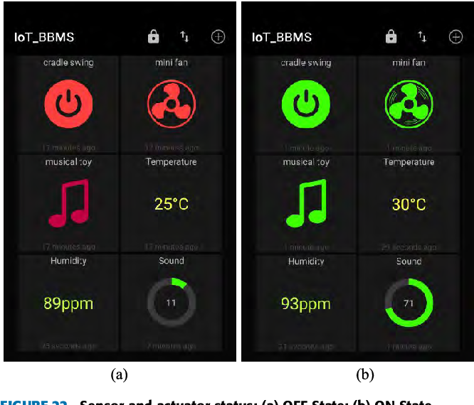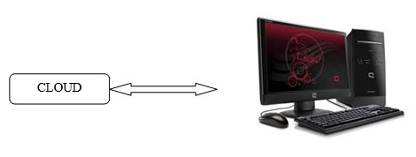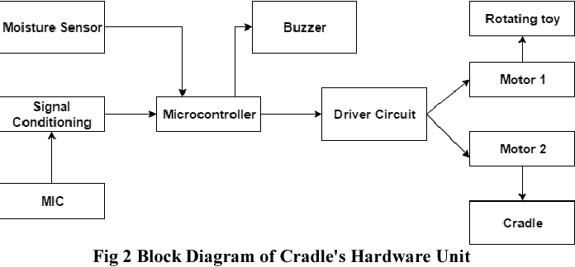

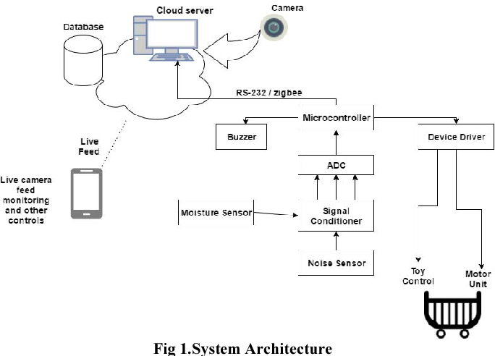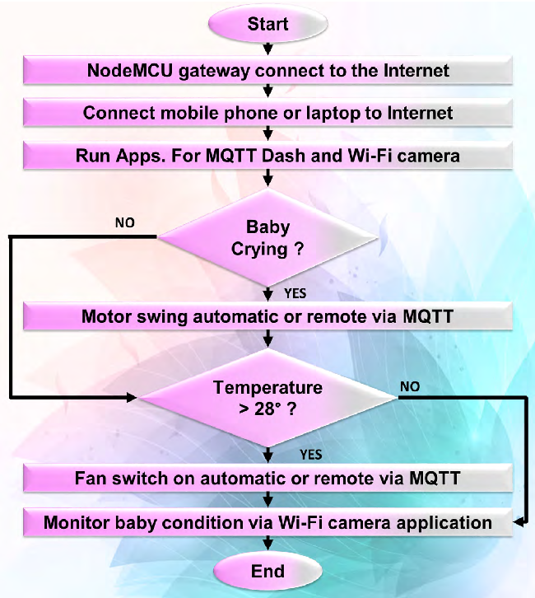

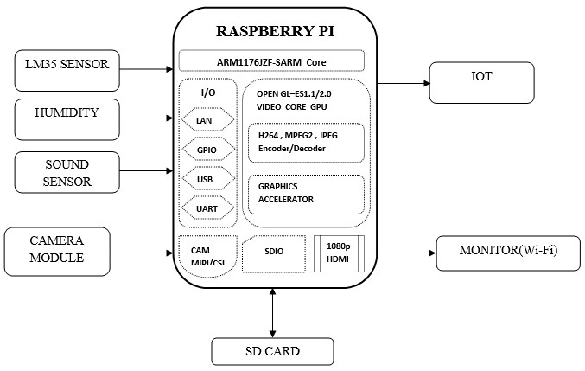

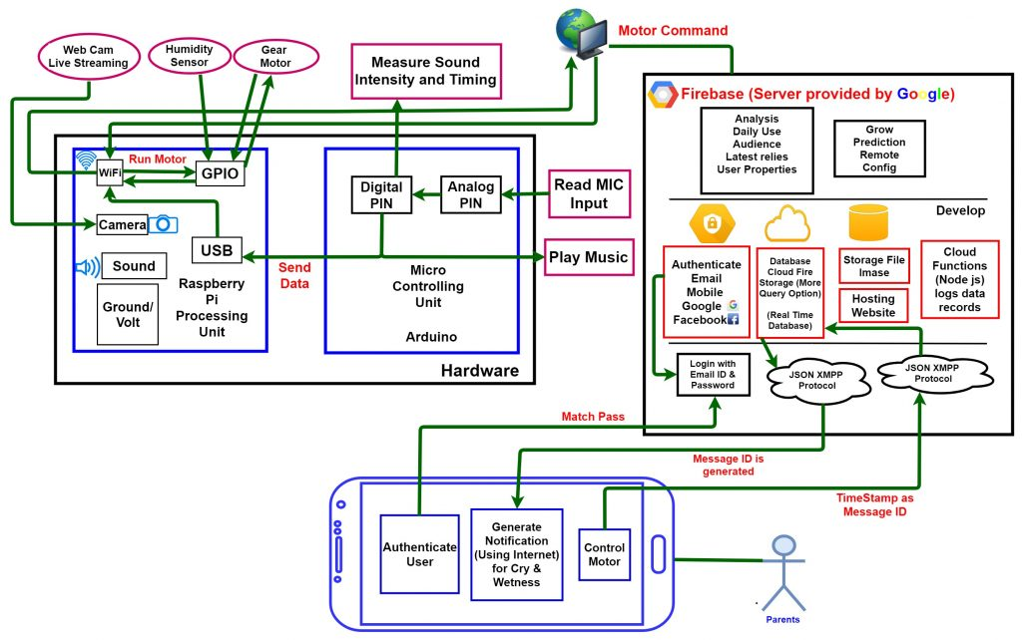

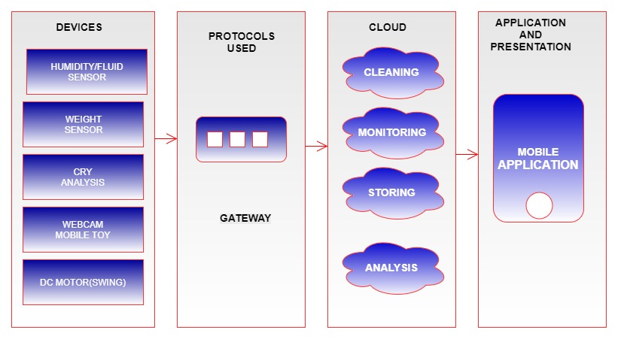

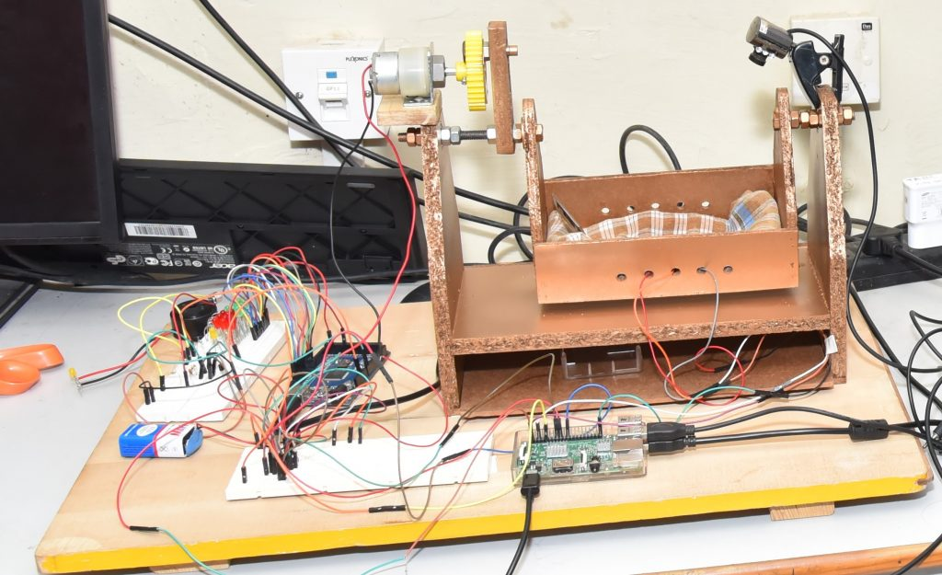

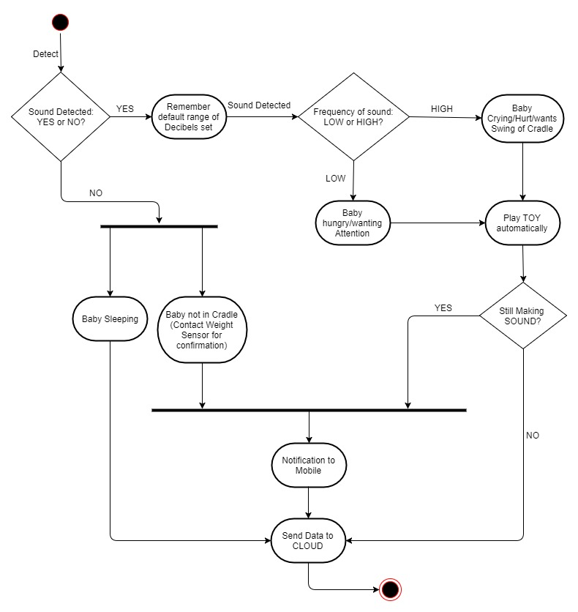

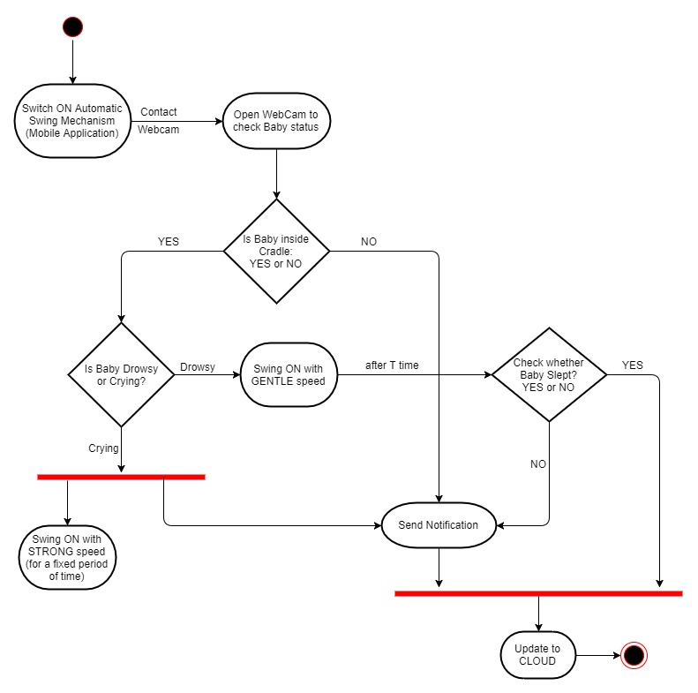

**Tools Used:**

* Software Used:
  1. Advanced IP Scanner
  2. PuTTY
  3. WinSCP
  4. Raspbian OS
  5. Arduino IDE – v 1.8.5
  6. Notepad++ – v 7.5.6
  7. Python IDLE – v 3.4
  8. Android Studio – v 3.0.1
* Hardware Used:
  1. Raspberry Pi 3
  2. Arduino Mega
  3. DHT11 Digital Temperature and Humidity Sensor
  4. Sound Microphone (Input)
  5. USB Camera
  6. NPN Transistors
  7. PN Junction Diodes
  8. IC chip (L293D)
  9. 10k ohm Resistors
  10. LEDs
  11. DC Motor (30 rpm)
  12. Plastic Gear
  13. 9v batteries

**Software Used:**

* Advanced IP Scanner:-

Reliable and free network scanner to analyse LAN. The program shows all network devices, gives you access to shared folders, provides remote control of computers (via RDP and Radmin), and can even remotely switch computers off. It is easy to use and runs as a portable edition. It should be the first choice for every network admin.

**The Best IP Address Scanners**

1. 1 — SolarWinds IP Address Tracker (FREE DOWNLOAD) ...
2. 2 — SolarWinds IP Address Manager (FREE TRIAL) ...
3. 3 — Advanced IP Scanner. ...
4. 4 — Angry IP Scanner. ...
5. 5 — SoftPerfect Network Scanner. ...
6. 6 — LizardSystems Network Scanner. ...
7. 7 — Bopup Scanner. ...
8. 8 — MyLanViewer Network/IP Scanner.

IP addressing is one of the most important aspects of any network administrator’s job. Each connected device needs an IP address, they must all be unique and there should never be an IP address conflict. With typical large organizations having thousands of devices, one needs some IP addressing tools just to ensure that everything is running smoothly. Gone are the days when a spreadsheet was all that was needed. As you shall soon discover, there are many types of IP addressing tools but today, we’re particularly interested in showing you **the best IP address tracker tools**.

**PuTTY:-**

PuTTY was originally written for Microsoft Windows, but it has been ported to various other operating systems. Official ports are available for some Unix-like platforms, with work-in-progress ports to Classic Mac OS and macOS, and unofficial ports have been contributed to platforms such as Symbian, Windows Mobile and Windows Phone.

PuTTY was written and is maintained primarily by Simon Tatham, a British programmer.

## Features:-

PuTTY supports many variations on the secure remote terminal, and provides user control over the SSH encryption key and protocol version, alternate ciphers such as AES, 3DES, Arcfour, Blowfish, DES, and Public-key authentication. PuTTY supports SSO through GSSAPI, including user provided GSSAPI DLLs. It also can emulate control sequences from xterm, VT220, VT102 or ECMA-48 terminal emulation, and allows local, remote, or dynamic [port forwarding](https://en.wikipedia.org/wiki/Port_forwarding) with SSH (including [X11](https://en.wikipedia.org/wiki/X11) forwarding). The network communication layer supports [IPv6](https://en.wikipedia.org/wiki/IPv6), and the SSH protocol supports the zlib@openssh.com delayed compression scheme. It can also be used with local serial port connections.

PuTTY comes bundled with command-line [SCP](https://en.wikipedia.org/wiki/Secure_copy) and [SFTP](https://en.wikipedia.org/wiki/SSH_file_transfer_protocol) clients, called "pscp" and "psftp" respectively, and plink, a command-line connection tool, used for non-interactive sessions.[[7]](https://en.wikipedia.org/wiki/PuTTY#cite_note-7)

PuTTY does not support [session tabs](https://en.wikipedia.org/wiki/Tabbed_document_interface) directly, but many wrappers are available that do.[[8]](https://en.wikipedia.org/wiki/PuTTY#cite_note-8)